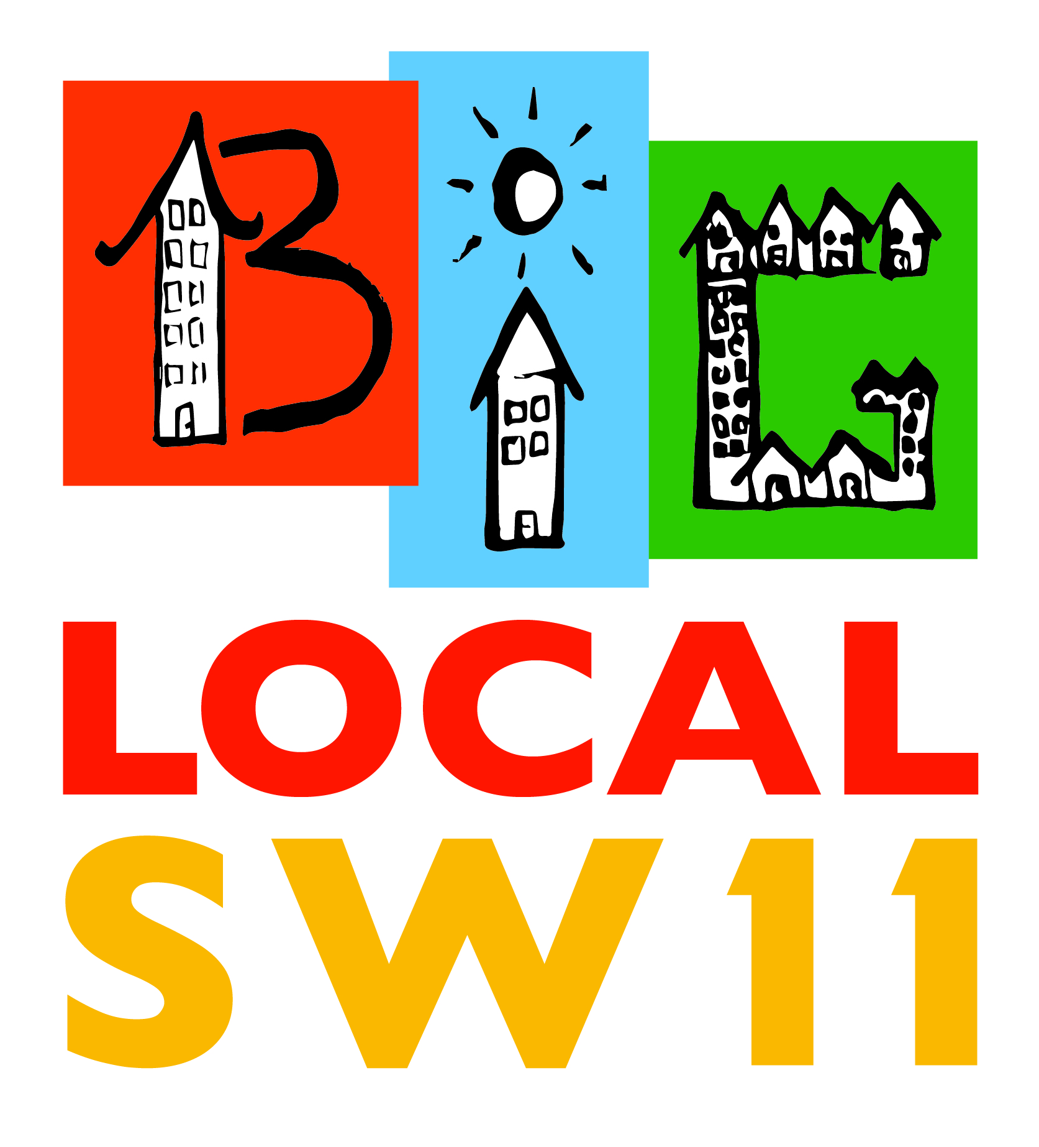
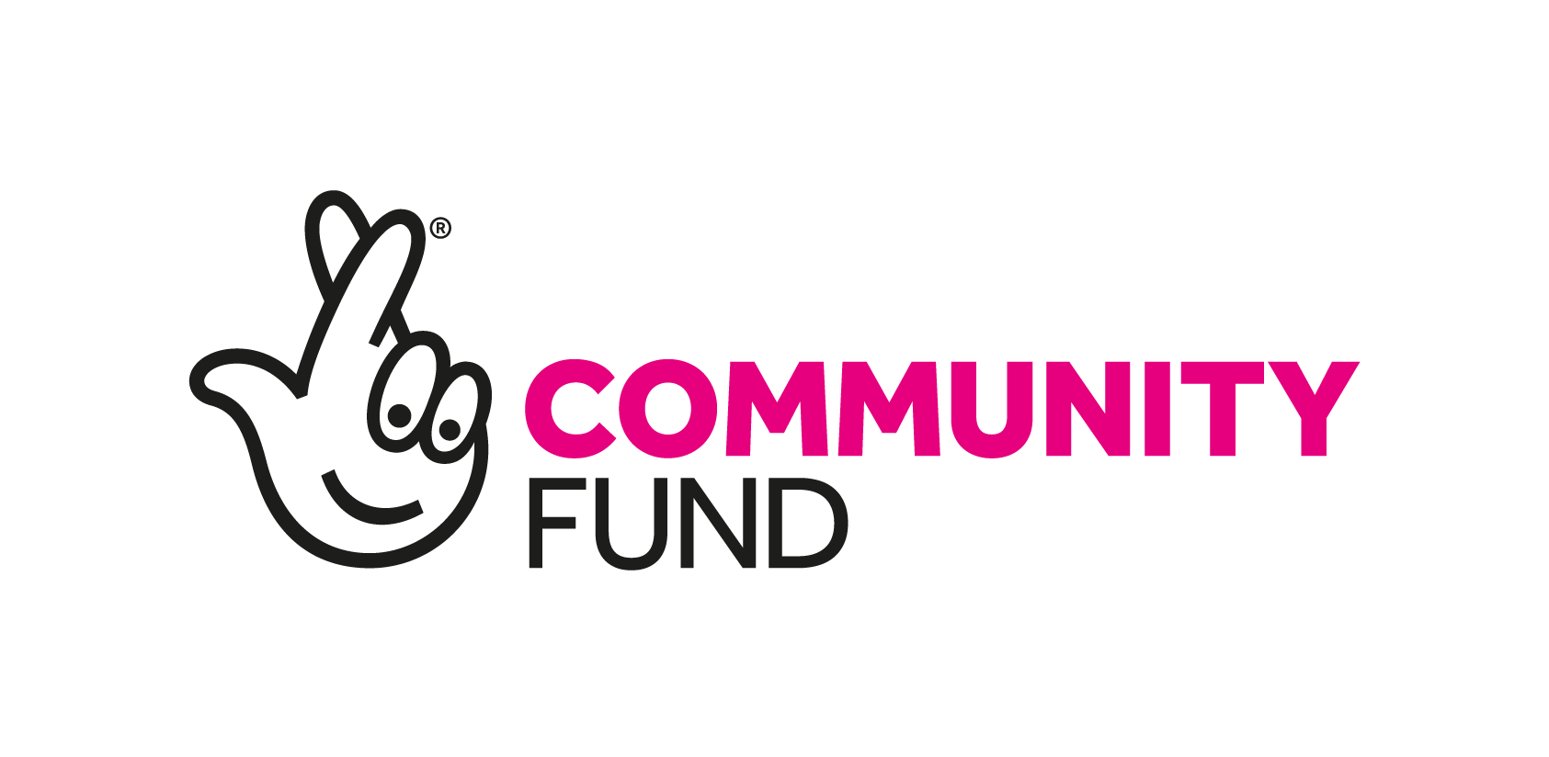
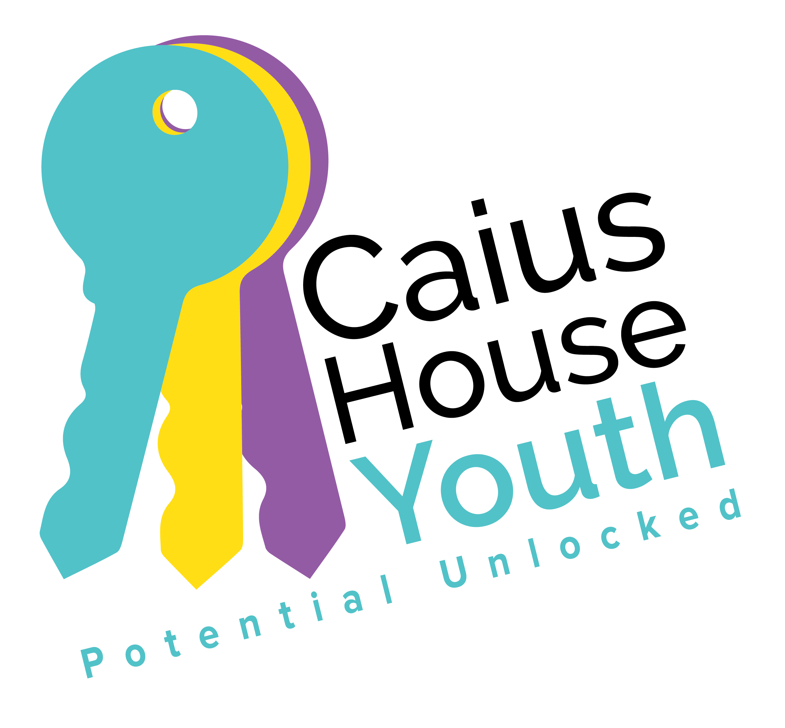
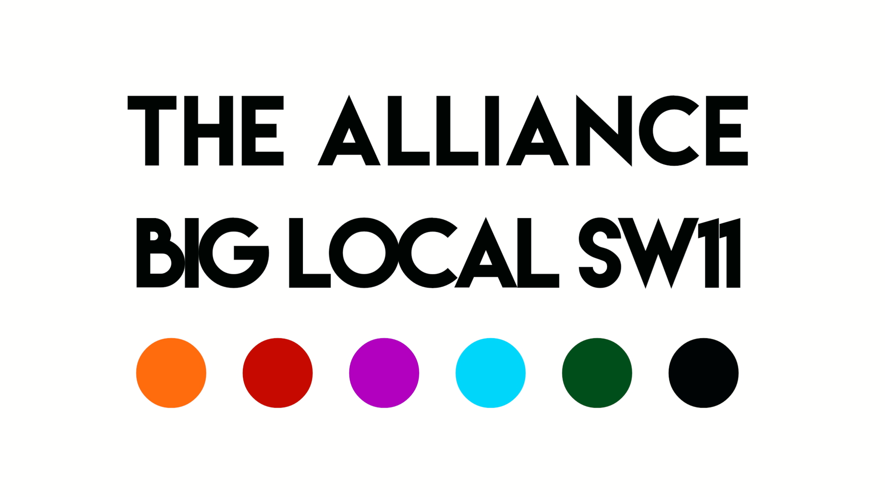

Battersea Youth Voice
A Funding Proposal to Big Local SW11

10th June 2020

Contact
Delrita Tester 07939 232 088
CEO deltester@caiushouse.org
Caius House www.caiushouse.org

Caius House is a registered charity no 1130066 and a company limited by guarantee no. 06758923
- Summary
This document outlines the proposal for the function of Battersea Youth Voice (BYV) and the recruitment of a Youth Development Coordinator. BYV is a key component of BLSW11’s three-year strategy. We are now ready to realise this project for the benefit of our community. This new project is a youth-driven education, training, mentoring and personal development programme with some of the most disadvantaged young people in Battersea, with the core group coming from the Big Local SW11 area.
Our ambition is for young people, who may otherwise feel disconnected from their community and society, to engage with and find solutions to issues (like depression and anxiety) by developing projects that connect with the wider community and develop skills useful for future employment and life.
- An introduction to BLSW11 and the Alliance
The Alliance has been formed by the Big Local SW11 (which is an independent, resident-led group that has been awarded £1m over 10 years to invest in projects that improve opportunities for local people and strengthen our community) to help delivery its own strategy of building a stronger, more self-reliant Battersea. Visit: www.biglocalsw11.co.uk
A partnership of five local long-standing, trusted and passionate organisations (Caius House, Carney’s Community, Katherine Low Settlement, Providence House, St Peter’s Church – see Appendix 1) we have deep community roots and social relations that span many generations. We are working together, alongside 30+ other local community delivery partners, to rebuild the social fabric of Battersea.
Note: The Alliance has a 7-year strategy that accompanies this proposal for Battersea Youth Voice.
2.a. Case Study: Building Social Capital in Battersea
Imagine Cairo who is eight. He goes to Providence House with his sister Charlene (10), as did his mother, her sister and brother, and their parents, and so on, so that Cairo is the great-grandson of one of first boys to attend. The kinship networks that belong to Cairo are part of the blood that flows through the arteries at the heart of the community of Battersea.
Over 50 years, hundreds of children directly, and several thousand people by association, have been part of one small cluster of experience that builds community. And through contact, connection and conversation, through real lived experiences, issues are addressed and problems resolved.
Imagine the many threads that weave together towards and away from Providence, multiplied many times through similar experiences from Carney’s, Caius, St Peters’ and Katherine Low Settlement, making the social fabric of Battersea, that share this in common – a safe place to be, built on trust!
The Alliance’ members have recognised that they could work much more closely together and have identified a further 50+ local Battersea based charities and community groups that they could work with too. Think what more can be achieved if we work better together.
- About Battersea and the Big Local SW11 Area
Hidden within the affluence of Wandsworth parts of Battersea are amongst the most deprived in London and the UK, with high unemployment, overcrowding, poor health and relative poverty. Latchmere and St Mary’s Park wards, where the Big Local SW11 Alliance focuses much of its work, rank in the most economically deprived 5% of the UK and over 40% of children live in a family dependent on income-related benefits.
Alongside the data on economic, social and environmental deprivation, the SW11 community has seen a significant reduction in statutory services provision designed to address these issues. Local Council budgets have on average reduced by 63% over last 10 years, which has caused a drastic reduction of local statutory services. These much-needed services are not universally reaching those that could most benefit from them in the community (low trust, narrow reach, high access thresholds, and over-stretched capacity).
The Alliance is motivated by the belief that stronger, more self-reliant communities provide answers to poverty, isolation and poor health (particularly depression and anxiety); and that building ‘social capital’ unlocks community capacity to address social and economic problems (unemployment, knife crime, low aspirations, disconnection from the community) far more effectively than ‘institutional’ or statutory approaches. This is because a strong community is built on social relations of trust and a deep knowledge of what is happening, to whom and where.
- The Alliance focus for the next 3 years
Over the next three years The Alliance plans to kick start the process of strengthening social capital, by building three components of ‘community infrastructure’ towards our longer term aim of rebuilding the social fabric of Battersea, namely:
- Battersea Youth Voice
- Volunteer Coordination
- Strengthening Community & Voluntary Sector organisations
The Big Local SW11 has a youth engagement and development strand to its strategy, making Battersea Youth Voice a cross cutting theme for The Alliance too. The following proposal focuses on creating and delivering Battersea Youth Voice. Separate proposals will be available for the Volunteer Coordination and Strengthening Organisations strands of work.
- About Battersea Youth Voice
Too many people in Battersea, of all ages, live in isolation, experience loneliness, anxiety and depression and do not participate in the community. While recognising the important work done by the statutory services and others to address these issues, we believe that a ‘community development approach’ has the potential to draw on the talent, skills, knowledge and experience of local people, so that they are better placed to find their own solutions.
As a first priority we plan to start with young people, as they are the future of our community. We plan to establish ‘Battersea Youth Voice’ (BYV): an education, training, mentoring and personal development programme with some of the most disadvantaged young people in Battersea, with the core group coming from the BLSW11 area. From our experience Battersea resonates with younger people as their connections/points of engagement, meeting places and safe spaces covering the whole of Battersea.
BYV will NOT be a talking shop, youth parliament or debating society! Our ambition is for young people, who may otherwise feel disconnected from their community and society, to engage with and find solutions to issues (particularly those identified by Big Local SW11’s research and a focus in their strategy of isolation, loneliness, mental health like depression and anxiety). BYV will engage young people in discussion about their ideas that might involve, for example, bullying on social media and the negative impact on their mental health; to then developing projects that address these as well as connect with the wider community, whilst developing skills useful for future employment and life.
5.a. Participation is key
We want our work to be youth driven and therefore need the active involvement of those young people who are experiencing and witnessing the issues that have a negative impact on our local community. We want to ensure that we are working with those young people who are not usually involved in these sorts of projects – those who are marginalised, excluded and unrepresented as they are deemed too ‘hard to reach’, ‘disruptive’ or ‘difficult to work’ due to their ‘challenging behaviour’.
Battersea Youth Voice will build on the extensive networks and relationships of three youth centres (Carney’s Community, Caius House and Providence House – all members of the BLSW11 Alliance – who have more than 170+ years’ experience of working in Battersea) to create an action and skills based environment. It will be driven by young people but supported by a professional youth development worker and local mentors.
Youth participation is important because it benefits the young people themselves, as well as youth groups and community as a whole. Young people become more confident and enthusiastic when they see that their views are being taken seriously and acted upon. It is here where they can feel an increased ownership of and responsibility for their local community. This in turn builds their self-esteem, as they gain new skills, and increases their appetite for getting more actively involved in other aspects of their lives, e.g. local community groups, sports clubs, school and politics.
If young people are involved in planning and decision-making, the youth group activities are more likely to be relevant and enjoyable for young people. This means young people are more likely to attend, and display more optimistic behaviours when they do so. It is by providing this inclusive environment that we aim to reach some of the most ‘hard to reach’ individuals.
Most importantly, it is the marginalised young people who are experiencing and witnessing, first hand, the negative impact of reduced services and support, such as children services, children centres, crime prevention services, mental health services, and a corresponding increase in child poverty. They must be actively involved – more than consulted – on what would be the best ways to challenge these issues and so improve the local community here in Battersea. These young people have social networks of their own (friends, acquaintances, immediate and extended family) that can help us bridge, as well as access, different communities that we are not necessarily in contact with but who are part of the solution to rebuilding the social fabric of Battersea.
From our research we know that BYV is not duplicating other Youth Forums in the area as there is no youth ’action’ based programme covering the Battersea area, nor one specifically targeting marginalised groups. BYV will feed into Wandsworth Youth Council, as well as into established panels/scrutiny groups/boards within the Council, NHS/CCG, Wandsworth Chamber of Commerce, Wandsworth Voluntary Sector Forum and more.
- Practicalities of Battersea Youth Voice
We will work with a core group of young people, initially over the next three years, to support their development as the next generation of civic leaders, entrepreneurs and homeowners.
6.a. Recruitment
We plan to recruit 10-15 young people as a core group, with a wider membership of 100-150 young people. Aged ideally 16-25 as they will have enough lived experience and maturity to contribute meaningfully. This age range also involves a transition into adulthood, which is a common time when young people experience that ’teachable moment’, when they decide what their role in life will be. BYV needs to be open to all with an emphasis on targeting marginalised and underrepresented young people, so this will mean thinking about different types of engagement and recruitment, such as:
- Having an open door policy is probably better than electing people into the group, as those marginalised are unlikely to put themselves forward, let alone conduct a campaign to ‘win’ votes.
- Encouraging the young people we know to help us do a lot of the wider recruitment and outreach.
- Taking referrals from our own 5 organisations and 30+ local community partners.
- Conducting face-to-face meetings at the Pupil Referral Units (PRU) and Youth Offending Team (YOT).
- Using incentives, such as introducing a Community Action Reward (CAR) – The CAR will reward people for their work in supporting BYV. This will act as an incentive for young people to get involved and reward them for doing so. In effect going some way to address the economic poverty of residents whilst getting them more involved in the local community. Wary of the benefit penalties that limits or prohibits payment to volunteers, our CAR will pay for such things as accredited training and skills development programmes.
- Using a questionnaire or potentially using popular social media platforms like Instagram and snapchat to gauge an interest (though this will probably not be that popular a method) and see what topics are highlighted as ones they feel need to be most addressed.
- Using HYV as a means to their own personal development e.g. it’s good for their long-term prospects, CV, employment etc. (especially if accreditation is possible).
Retention and continuity will be important to ensure the success of BYV. We know that building relationships is achieved by keeping connected. For example, we find that many of our young people appreciate weekly phone calls or home visits to check in with them, see how they’re doing and remind them of the activities they attend. Again through our experience this is a good way of maintaining good attendance, as well as developing a strong relationship with members.
Involving the immediate family is an important factor of our work. We are not operating in isolation and are part of a ‘network of support’ that each young person will (generally) have. We keep connected, regularly talking and communicating with parents, relatives, carers, social services about the care and support we are giving, as well as updates about how each young person is from week to week. Enabling everyone to provide a co-ordinated approach to their care.
6.b. Approach
Any programmes developed through BYV will be member- and evidence-led, developed in a responsive, participative, inclusive manner. This ensures that we are truly providing quality services that the young people actually want and value to help improve their lives and solve the problems that are important to them and the local community. From our initial contact with young people, we will build a collaborative relationship enabling us to respond creatively to their needs and foster a caring and giving approach, with all members contributing whatever they are able. We subscribe to the view that ‘empowering’ young people within the context of a broader community development programme will help produce the next generation of community activists, civic leaders and entrepreneurs.
6.c. Format
In addition to the core group, there will be sub-groups depending on what themes arise. BYV could involve regular meetings or events but based around specific topics or themes or with a specific goal around consultation. We may have to do one-to-one work with some young people, who may not be comfortable in a group. There is also the option of having some virtual meetings using Vroom for example, which is an app that puts all parties on a single screen to discuss topics. We should look at big local topics such as knife crime, relationships, mental health, school, intergenerational work but also aim to get some small wins in quickly to help encourage them. We will develop a mechanism to turn their ideas and recommendations into practical solutions. Remember this is not a talking shop! A project budget is needed to facilitate this.
BYV needs to not be a gimmick but should be meaningful. We need to ensure that we are not overly influencing the group – empowerment within a context. This will come down to the values and experience of the Youth Development Worker we recruit, to guide and support the young people.
Team bonding will be necessary for most of the group, so activities, meetings and a residential will be planned. We would ideally start with a residential to build the bonds and trust needed to progress. The local Scout centre has been recommended. They could also provide relevant training to the young people.
6.d. Training
On-going training will be needed for the young people involved in, for example, community development, project planning, Planning for Real, participation techniques etc. We will provide this in-house and/or bring in trainers us to help up-skill the young people.
6.e. Monitoring and Evaluation
We need to be really clear about what we want the group to achieve and ensure we highlight what they do achieve. We will develop a monitoring and evaluation framework with the young people. This could include some sort of baseline assessment for all of those in the group, to monitor their development over time (see below for more details). However, we are aware that baseline assessments can act as a barrier to some of the more disengaged young people, so we will also explore ideas around doing baseline assessment with other professionals that know or have worked with the young person. We would like the Youth Development Worker to see how they can do these sort of assessments online or through social media, to make them more accessible and attractive to the young people.
6.f. Accreditation
It may be beneficial for some of the young people to gain some form of accreditation. The Alliance will explore becoming an AQA accredited centre or linking in with Jack Petchey Awards or Duke of Edinburgh Awards.
- Outputs and Outcomes
We will use the following monitoring framework to help us measure our progress. However, until we start to engage with and develop these with the young people themselves then the following are only estimates. By investing in BYV and other Community Infrastructure, over the long term, we foresee a range of outcomes that in combination will evidence the rebuilding of the social fabric of Battersea.
7.a. Outputs (estimated)
Activities / Outputs | Year 1 targets | Year 2 targets | Year 3 targets | Indicators
No. of Young People involved in BYV | 10-15  core group  100-150  wider group | 10-15  core group  100-150  wider group | 10-15  core group  100-150  wider group | Referral and assessment register  Attendance register
Gaining Skills | 24 | 24 | 24 | Questionnaires (self-reported)  Exam results/records  On-going staff records and observations
Qualifications | 0 | 6 | 12 | Exam results/records  On-going staff records and observations
Leading Projects | 8 | 8 | 8 | On-going staff records and observations  Attendance register
Employment | 0 | 5 | 5 | On-going staff records and observations  Contract of employment
Mentoring | 8 | 8 | 8 | On-going staff records and observations  Attendance register
Developing Social Enterprises | 0 | 1 | 2 | On-going staff records and observations  Course attendance and/or business registration

7.b. Outcomes (estimated)
Difference /  Outcomes | Year 1 targets | Year 2 targets | Year 3 targets | Indicators
Increased Confidence | 90% make a contribution to BYV | 90% make a contribution to BYV | 90% make a contribution to BYV | Initial Assessments  On-going staff records and observations  Annual appraisal with members
Enhanced Social Skills | 80% are actively engaged and involved with BYV making new friends with peers and staff | 80% are actively engaged and involved with BYV making new friends with peers and staff | 80% are actively engaged and involved with BYV making new friends with peers and staff | Initial Assessments  Attendance Register  On-going staff records and observations  Annual appraisal with members
Rising Aspirations | 75% increase their level and depth of understanding about their own aspirations and opportunities available | 75% increase their level and depth of understanding about their own aspirations and opportunities available | 75% increase their level and depth of understanding about their own aspirations and opportunities available | Initial Assessments  Weekly Attendance Register  On-going staff records and observations  Annual appraisal with members
Increased positivity about Battersea/SW11 | 75% have a better understanding about what goes on it Battersea and where to access support | 75% have a better understanding about what goes on it Battersea and where to access support | 75% have a better understanding about what goes on it Battersea and where to access support | Initial Assessments  Attendance Register  On-going staff records and observations  Annual appraisal with members
Increased participation in the local community | 50% increase in volunteering in local organisations, such as community groups, sports clubs | 50% increase in volunteering in local organisations, such as community groups, sports clubs | 50% increase in volunteering in local organisations, such as community groups, sports clubs | Initial Assessments  Attendance Register  On-going staff records and observations  Annual appraisal with members

The work of BYV, though not directed towards employment outcomes will have a direct bearing on ‘employability’, through the creation of an environment in which young people can develop social skills, build their confidence and self-belief, and ultimately technical skills and knowledge through project planning and delivery that will open up opportunities for educational advancement and potentially the development of social enterprises.

7.c. Evaluation
The scope of the project evaluation will be to determine the extent to which the project has succeeded in realising its outcomes, outputs and delivery activities. A participant-orientated summative evaluation will be conducted – placing the young people and stakeholder at the heart of the evaluation. We work in a participative manner so will work with our young people to identify appropriate indicators and then develop relevant self-reported data collection methods – to assess whether the project met its outcomes, whether there were any unintended consequences, what were the learnings, and how to improve the project.
These include using a baseline survey (written, audio, video where appropriate), observations by staff, mid-term discussion groups and endpoint questionnaire. Outputs will include measuring numbers attending and frequency, demographics and number of activities. A final report (including case studies) will be submitted upon completion.
- Staff and Volunteer Team
We have an experienced and highly qualified team of staff and volunteers who will run Battersea Youth Voice:
Youth Development Coordinator (to be recruited) – BYV will appoint a highly experienced and competent Youth Development Worker who will be able to work across the community and through The Alliance’s established youth centres. After an initial scoping phase, a 1-year indicative plan will be developed, including key indicators, that will be used to track performance, successes as well as challenges.
This post will be recruited online (e.g. CharityJob, London Youth), via the Alliance member’s websites, social media channels and local ‘real life’ charity and community networks, as well as through local/regional youth and community networks.
Delrita Tester, Manager – The day-to-day operations of BYV will be managed by Caius House’s CEO, who has over 20+ years’ experience of working with young people.
Alliance: Youth Workers – 3-4 experienced Youth Workers from Caius House, Carney’s Community, Katherine Low Settlement and Providence House (all members of The Alliance) will support the Youth Development Coordinator and BYV in its development. A bank of hours will be available for various staff to get involved and support BYV.
Volunteers – A small team of 3-5 volunteers will be recruited and trained to support BYV’s development.
- Ensuring Quality
To ensure quality we will manage BYV as follows:
- Oversight by The Alliance steering group: Made up of five CEO’s and Senior Managers from 5 well-established local Battersea charities, they will take responsibility for strategic oversight of Battersea Youth Voice. Acting as a ‘critical friend’, helping to steer, advise and guide the programme as appropriate. They already meet monthly (as we have done for more than 2 years), and are available for additional support via telephone and email.
- Performance reports to the BLSW11 Board: The Board approved The Alliance’s 7-year strategy in 2018, included in which were quarterly reporting mechanisms, a risk register, and up-to-date organisational policies, to ensure high-standards of our services, staff, volunteers and users.
- Regular self-assessment by the project team: Effective staff support and line management is key to any successful project. To this aim the project staff, volunteers and manager hold regular (weekly/monthly) project team meetings and regular individual staff supervision sessions to ensure that the programme is meeting its targets, rewarding performance, troubleshooting and measuring results.
The Alliance believes that a continuous improvement approach is essential to maintain and develop service quality. This takes the form of addressing challenges, user feedback, new research, information from training and partnership work, and celebrating successes. Staff, volunteers and our users work together to continuously learn and improve. In matters of quality, organisations cannot stand still.
- Risks & Mitigations
Risk | Mitigation | Likelihood & Impact
New project – not done before | The Alliance’s 5 charities are very experienced (300+ collective years) in setting up new projects and working with marginalised young people. We have consulted with young people and have been building BYV with them. We will monitor and evaluate the project every step of the way. | Low
Recruiting the right Youth Development Worker will be key | The Alliance has more than 50+ staff between them, and more than 1,300 volunteers. We are experienced in recruiting, inducting and supporting new staff. We will advertise widely and have a probation period if things don’t work out. | Low
Difficult to recruit and involve marginalised young people | We have a strong recruitment plan in place (see above) and an experienced team to do so. Caius, who is managing BYV, has worked with young people over the last 100+ years. BYV will also be supported by three other experienced youth centres, who are part of The Alliance. Saying this, working with disaffected young people is challenging and we may encounter some resistance to recruiting them onto BYV in the first place and then encouraging them to stay involved. A strong monitoring and evaluation process will be built in from the beginning. | Low
Full funding is not immediately available | We will aim to use the initial BLSW11/JV investment to secure match funding from Tideway, Wates, Battersea Power Station Foundation | Medium

- Timetable
We’d look to recruit someone to fill this new position as soon as funding was granted for a three-year period. The recruitment process usually takes 2-3 months. Within this 3-year timeframe we would expect the new staff member to strengthen the business case with evidence of success and to identify possible sources of future funding for their post to continue.
- Further Information
If you would like to discuss any of this proposal in more detail and/or would like to visit to see our work in action then please do get in touch with Delrita Tester, CEO of Caius House on 07939 232 088 and deltester@caiushouse.org

Appendix 1 – Who’s Who in the Big Local SW11 Alliance
The Big Local SW11 Alliance is a place-based partnership, with strong roots in the local community and over 300 years of collective experience. It includes the following Battersea community organisations:
Big Local SW11
Big Local SW11 is an independent, resident-led group that has been awarded £1m to invest in projects, over a 10-year period, that improve opportunities for local people and strengthen our community in Battersea. Visit: www.biglocalsw11.co.uk
Caius House
Caius House is a centre of excellence, founded in 1887, where the potential inherent in every young person can be unlocked. With our unique team of experienced youth workers, educators, musicians, counsellors, trained dancers and media specialists we are able to support individuals and provide targeted programmes to encourage each young person to develop their individual skills and talents. Visit: www.caiushouse.org
Carney’s Community
Carney’s Community has been using boxing and intensive mentoring since 2011 to get disadvantaged and excluded young people away from a life of crime and despair. Carney’s gives them skills, discipline and self-respect. Our aim is to reduce offending, re-offending and anti-social behaviour, whilst improving social mobility and community cohesion. Visit: www.carneyscommunity.org
Katherine Low Settlement
Katherine Low Settlement is a much-loved, busy charity that has been serving Battersea and the wider Wandsworth community since 1924. Our vision is for an inclusive society where people achieve their potential together. We foster and empower communities in our neighbourhood to reduce poverty and isolation. We run a range of our own community projects to support children, young people and families, older people and refugee communities. Each week we work with 45+ charities and community groups supporting more than 1,100 people. Visit www.klsettlement.org.uk
Providence House
Providence House Youth Club has been passionate about improving the lives and outcomes for young people Battersea and beyond. Established in 1963, we continue to provide social, recreational, sporting and outdoor residential educational activities for young people and families. Our mission is to share the Christian message of Jesus Christ and to walk with young people, families and the local community in their life journeys. We are ‘here for all’. Visit: www.providence-house.org
St. Peter’s Church
St. Peter’s is a lively, diverse and growing church family whose vision is: loving God, being family, bringing hope – in Battersea and beyond. The church has been serving the local community since 1875, and they’ve just moved into a purpose-built building where they run activities for all ages. They place a high value on participation, community and diversity. Visit: www.spb.church
Other Battersea Partners
In addition to the Alliance members we have identified more than 50 local delivery partners, who have the local knowledge, relationships of trust and community services, that will be needed to rebuild the social fabric of Battersea.

Appendix 2 – Job Description
Battersea Youth Voice – Youth Development Coordinator

Job Description

Job Title: Battersea Youth Voice – Youth Development Coordinator (new post)
Position: Permanent
Salary: £31,000-£33,000 (depending on experience)
Pension: 8% employer’s contribution
Hours: 35 hours/week
Holidays: 28 days including Bank Holidays per year (pro rata)
Responsible to: Caius House CEO
Location: Battersea, London Borough of Wandsworth

About Caius House
Caius House is a centre of excellence where the potential inherent in every young person can be unlocked. With our unique team of experienced youth workers, educators, musicians, counsellors, trained dancers and media specialists we are able to support individuals and provide targeted programmes to encourage each young person to develop their individual skills and talents.
Visit: www.caiushouse.org
About Big Local SW11 Alliance

The Alliance has been formed by the Big Local SW11 (which is an independent, resident-led group that has been awarded £1m over 10 years to invest in projects that improve opportunities for local people and strengthen our community) to help delivery its own strategy of building a stronger, more self-reliant Battersea.
Visit: www.biglocalsw11.co.uk
A partnership of five local long-standing, trusted and passionate organisations (Caius House, Carney’s Community, Katherine Low Settlement, Providence House, St Peter’s Church – see Appendix 1) we have deep community roots and social relations that span many generations. We are working together, alongside 30+ other local community delivery partners, to rebuild the social fabric of Battersea.
About Battersea Youth Voice
The Alliance plans to establish ‘Battersea Youth Voice’ (BYV): an education, training, mentoring and personal development programme with some of the most disadvantaged young people in Battersea, with the core group coming from the BLSW11 area.
BYV will NOT be a talking shop, youth parliament or debating society! Our ambition is for young people, who may otherwise feel disconnected from their community and society, to engage with and find solutions to issues (like depression and anxiety) by developing projects that connect with the wider community and develop skills useful for future employment and life.

Key Objectives for this role
This is an exciting new developmental role, whose principle purpose is to recruit, engage and co-ordinate a group of local young people with the aim of enabling and empowering them to ensure their voices are heard and bring about change. This may include increasing their levels of confidence, improving their communication skills and improving their ability to self-advocate. We envisage that the young people engaged will develop new projects and services in response to their needs and that of the local community.
Whilst ‘Battersea Youth Voice’ will be open to all young people, the Coordinator’s main role will be to target those young people that have been marginalised, deemed of as ‘hard to reach’ and who rarely have their voices heard.
Duties and Responsibilities
- Planning
- Support the planning of Battersea Youth Voice (BYV) with young people themselves, The Alliance charities, local partners and funders.
- Delivery
- Use a ‘community development’ approach to undertake participatory promotion activities to recruit young people.
- Manage referral and assessment process.
- Conduct outreach work with young people in the community including home visits.
- Support young people – one-to-one support, as well as group work – in the development and delivery of new services and activities for young people and the wider community.
- Link and work with appropriate Alliance charities and other youth agencies.
- Report and address safeguarding issues.
- To be part of and work closely with the Elders team and other KLS teams.

- Relationships and networks
- Build and sustain strong relationships with local young people and their families.
- Build on our strong relationships with local partners including Alliance charities, youth agencies, schools and council services through networking, conferences, training and meetings.
- Actively network to develop our relationships with other voluntary and community organisations, statutory bodies, businesses, funders and commissioners.
- Finance and fundraising
- Manage the project budget, maintain financial records, monitor income and expenditure against budgets and targets, and report regularly and accurately to Caius House and The Alliance’s steering group. Effective risk management is key for all our services.
- Work in co-ordination with The Alliance Steering Group to fundraise and secure financial viability and future sustainability for Battersea Youth Voice.
- Monitor and Evaluation
- Ensure performance management and quality systems are in place to monitor and evaluate the project’s work, processes and safeguarding.
- Manage Volunteers
- Take responsibility for managing individual volunteers as and when appropriate

- Undertake Other Duties
- Participate in regular management supervision and annual appraisal; help to identify your own job related development and training needs.
- Undertake your role in a professional manner and maintain a high quality standard of work in accordance with the aims, values and ethos of KLS
The above job description reflects the position at the time of writing; it is not intended to be a task list but indicates the general level of work involved. It is expected that duties will be reviewed and revised as required.
Skills and Experience | Essential/  Desirable
Suitable recognised qualifications. Youth and Community Qualifications (minimum Level 2, Level 3 preferable) or equivalent qualification and/or a proven track record of successfully working with Youth and Young Adults including Offenders or those at risk of offending or those deemed to be vulnerable | E
Clear commitment to the aims, objectives and values of The Big Local SW11 Alliance. | E
Track record of working with vulnerable, hard to reach and disadvantaged youth and/or young adults. | E
Contemporary appreciation and understanding of safeguarding issues - both in theory and in practice. | E
Excellent people skills. Leader or facilitator. You will be a strong negotiator, able to set clear boundaries whilst empowering the young people you are targeting. | E
Excellent organisational and administrative skills. The ability to work under pressure, with minimal supervision and to prioritise a varied workload. | E
Proven ability to be compassionately present for young people with complex needs. | E
Evidenced flexibility and the dexterity to work as part of a team. | E
An ability to work unsupervised. A resourceful, pro-active approach with a high level of initiative. Capacity to analyse problems and identify solutions. | E
A track record of being punctual and reliable. | E
Good working knowledge of IT systems (including Word, Excel, email, social media etc). | E
A confident and assertive personality, combined with an aptitude to carry out duties with good humour, tact and diplomacy. | E
Knowledge of Battersea and Wandsworth. | D
Risk management and health & safety experience. | D
Knowledge of both health & safety and first aid (Training in current regulations and practice will be offered to the successful applicant). | D

Further Information
For further information and an informal chat about this post please contact Delrita Tester, CEO of Caius House on 020 3818 6210 and deltester@caiushouse.org
- Caius House is committed to equal opportunities.
- All offers to work at Caius House are subject to two satisfactory references, which is standard Caius House policy applicable to all roles. Caius House also ask for an enhanced DBS check.
- You will adhere to matters of confidentiality concerning this role, Caius House team and The BLSW11 Alliance.
- An induction is given to all staff. This includes sharing Caius House policies / procedures relevant to each post.
- There is a 6-month probation period for this role.

Appendix 3: The Big Local SW11 Alliance strategy
The Alliance is a lead group of five local long-standing, trusted and passionate organisations, with deep community roots and social relations that span many generations, working together to build a stronger Battersea, that will work in partnership with other local community delivery partners.
The Alliance has already started to deliver! In 2018/19 Providence House, Caius House, St Peter’s church, Carney’s Community and Katherine Low Settlement worked together to:
- Establish a system of interagency referrals, so that young people have much more on offer than belonging to one club!
- Ran a highly successful Summer Programme
- Developed the Urban Arts Festival
- Led in the development and delivery of the first Battersea Charity Week (June 2019) – with 98 people from 61 organisations attending!
- Delivered an Intergenerational project
- Participated in the first Wandsworth Voluntary Sector Conference (May 2019)
- Met with MP Marsha De Cordova, to (amongst other things) lobby on behalf of Battersea Youth Voice.
By 2024 the Big Local SW11 Alliance will address the main priorities for Battersea by mobilising 7,000 local people and organisations in Battersea to co-produce a host of multi-facetted, creative and effective services, activities and events, including: housing, health and wellbeing, mental health, arts & culture, (un)employment, sports, advice and guidance, disability, environment, children and young people, families, elders, refugees, and more… All of which will contribute to realising our vision of rebuilding the social fabric of the community in Battersea.
Note: A copy of The Alliance’s strategy is available upon request.

Appendix 4: State of the Community Voluntary Sector in SW11
Working Across the Community Voluntary Sector in SW11
In September 2018 Big Local SW11 published its ‘The State of the Sector’ report.
The key findings were:
- Approximately 364 people work in the Community Voluntary Sector in BLSW11
- There are approximately 1,339 volunteers
- About 1,646 volunteer hours are worked each week
- Based on salaries alone the ‘value’ of the Community Voluntary Sector in BLSW11 is worth between £10-£12m per annum
- We estimate that the Sector generates £10m in turnover
- The ‘value’ of volunteering is estimated at £903,000 per annum (based on a London Living Wage equivalent value of £17,365 generated per week)
- Areas that appear to have ‘good’ coverage include: Youth, Religion, Education and Wellbeing
- Areas that appear to have ‘poor’ coverage include: Mental Health, Isolation, Environment and Poverty
Of the 55 organisations consulted during the research, 33 expressed a strong interest in working with Big Local SW11. This provides a real opportunity for any additional funds that Big Local SW11 can attract into the community to be channelled through our local organisations as ‘delivery partners’.
A key aim of our strategy is to see the development of a stronger, more vibrant and resilient community voluntary sector, that is less vulnerable to the vagaries of ad hoc occasional grants and shifts in national, regional and local policies.
Note: A copy of this report is available upon request.
Appendix 5: Big Local SW11 Area of Impact and Influence
The Big Local SW11 area consists of a group of council estates lying to the north of Clapham Junction station (covering the wards of Latchmere and part of St Mary’s Park), in the London Borough of Wandsworth. The largest is the Winstanley Estate which together with the York Road, Falcon, Kambala, Badric Court and Wayland Road estates, make up a community of around 10,000 people.
This community includes some of the most densely housed parts of Latchmere and parts of the population that are amongst the most ‘deprived’ in the Borough (and London).
While Big Local SW11 is primarily focused on delivering benefits for residents of its eligible area, we recognise that many services and opportunities for local people may lie outside the physical ‘zone’ of the BLSW11 area. From our experience Battersea resonates with younger people as their connections/points of engagement, meeting places and safe spaces covering the whole of Battersea.
The Alliance aims to engage with and deliver services across Battersea.
The map below shows for the full extent of the Big Local SW11 geographic area.
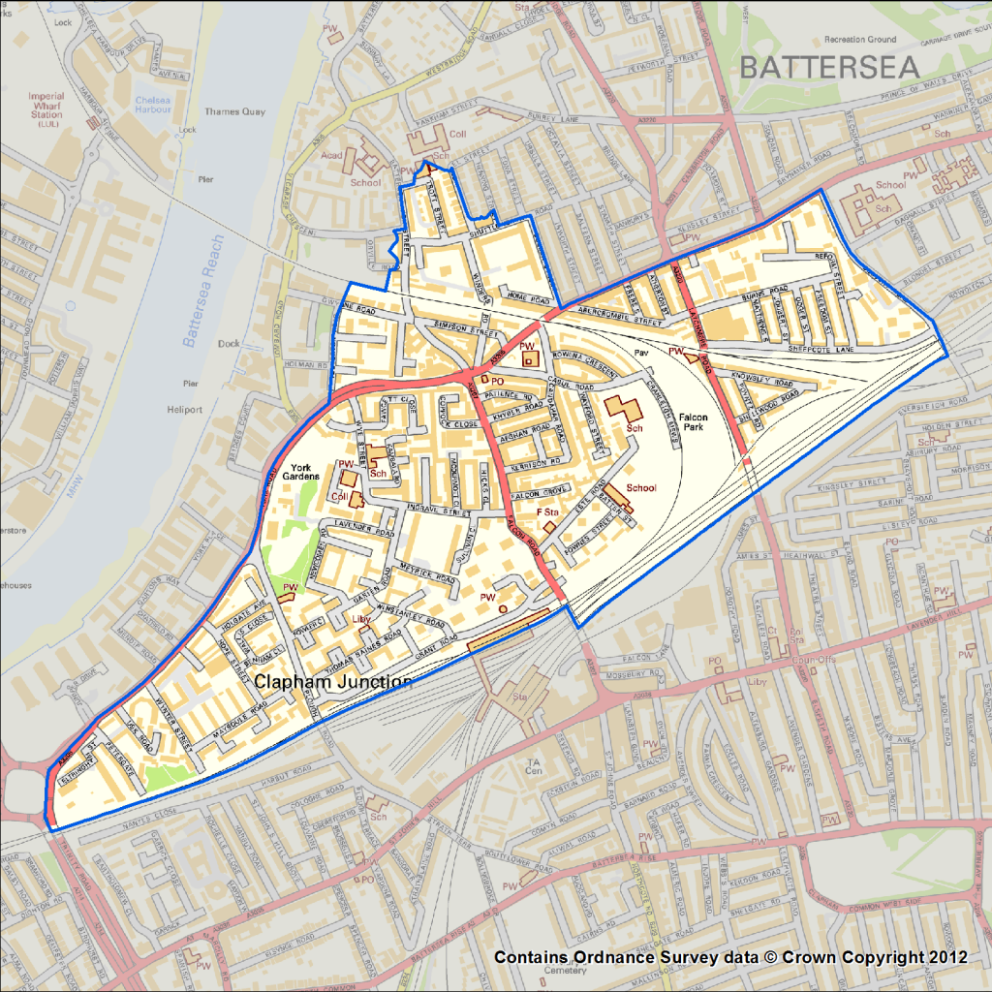

Principle data sources: Big Local SW11, 2014-2018; Census, 2011; Citizens Advice Wandsworth, 2015/16; DCLG’s IMD, 2015; London Poverty Profile, 2017; Public Health England, 2017; Wandsworth JSNA, 2018
Social Capital: the ‘bonds’ that tie people, the ‘bridges’ that connect people, the places and spaces where people meet.
Community development is defined as “a process where community members come together to take collective action and generate solutions to common problems.” (United Nations, 2014)
We understand that the CAR initiative will need to conform to the legal requirements of the benefits and HRC systems
10% of Battersea’s population

